**CHAPTER-1**

**PLANTATION AND ADOPTATION OF A TREES**

**WHAT IS PLANTATION AND ADOPTATION?**

A **tree plantation, forest plantation**, **plantation forest**, **timber plantation** or **tree farm** is a forest planted for high volume production of wood, usually by planting one type of tree as a **monoculture forest**. The term *tree farm* also is used to refer to tree to tree nurseries. **Plantation forestry** can produce a high volume of wood in a short period of time.

Tree Adoption is interpreted as **a public reward given to a community for its contributions to tree care based on an agreed mechanism between said community and the customary forest group**. A person willing to participate in tree adaption will hereafter is referred to as the caregiver of a tree in customary forest.

**WHY IS TREE PLANTATION NECESSARY?**

Tree plantation is very necessary because **trees provide oxygen to the environment and make the air quality better**. If more trees are planted, then the world's environment will become a safer place to live in. Tree plantation also reduces pollution, thus making the life of future generations secure.

**BENEFITS OF TREE PLANTATION**

* **TREES FOR WILDLIFE** - **Trees support the lives of many large organisms**. Trees are used for food, shelter, and as sites for reproduction. Many animals also use trees for resting, nesting and for places from which to hunt or capture prey. During times of extreme heat or precipitation, animals seek shade and shelter under the trees without being away from their food source; the shade helps them regulate their body temperatures.
* **PREVENTING SOIL EROSION, REDUCING FLOODS***-*Canopies intercept rainfall, delay and reduce the impact of the drops falling onto the ground, thereby reducing runoff and avoiding soil erosion which leads to decrease in river capacity and to flooding,
* **REMOVING POLLUTANTS -** **Trees clean the air, remove dust and particulates, absorb ozone, carbon monoxide, sulfur dioxide and other pollutants, through the stomata in the leaf surface** .
* **CLEAN WATER**: **Trees act as natural pollution filters for water**. Their canopies, trunks, roots, and associated soil and other natural elements of the landscape filter polluted particulate matter out of the flow, reducing the amount of pollution that is washed into a drainage area. Trees use nutrients like nitrogen, phosphorus, and potassium which can pollute streams.
* **Trees create jobs, provide flowers, fruit, fodder and fuel to communities and living creatures, offer shade to nomads and their livestock, give shelter to birds and animals, prevent soil erosion and flooding, improve water catchment, generate oxygen, reduce pollution and benefit posterity while decarbonizes  the atmosphere.**

**Fig 1.1:** Arecanut plantation

**ARECA PALM (ARECANUT)**

|  |  |
| --- | --- |
| Kingdom: | [Plantae](https://en.wikipedia.org/wiki/Plant) |
| *Clade*: | [Tracheophytes](https://en.wikipedia.org/wiki/Vascular_plant) |
| *Clade*: | [Angiosperms](https://en.wikipedia.org/wiki/Flowering_plant) |
| *Clade*: | [Monocots](https://en.wikipedia.org/wiki/Monocotyledon) |
| *Clade*: | [Commelinids](https://en.wikipedia.org/wiki/Commelinids) |
| Order: | [Arecales](https://en.wikipedia.org/wiki/Arecales) |
| Family: | [Arecaceae](https://en.wikipedia.org/wiki/Arecaceae) |
| Genus: | [*Areca*](https://en.wikipedia.org/wiki/Areca) |
| Species: | 1. ***catechu*** |

***Areca catechu*** is a species of palm which grows in much of the tropical Pacific, Asia, and parts of east Africa. The palm is believed to have originated in the Philippines, but is widespread in cultivation and is considered naturalized in southern China , Taiwan, India, Bangladesh, Sri Lanka, Cambodia, Laos, Thailand, Vietnam, Malaysia, Indonesia, New Guinea, many of the islands in the Pacific Ocean, and also in the West Indies.

**Fig 1.2:**Arecanut

Common names in English include **areca palm**, **areca nut palm**, **betel palm**, **betel nut palm**, **Indian nut**, **Pinang palm** and **catechu**. In English this palm is called the **betel tree** because its fruit, the [areca nut](https://en.wikipedia.org/wiki/Areca_nut), is often [chewed along](https://en.wikipedia.org/wiki/Paan) with the [betel leaf](https://en.wikipedia.org/wiki/Betel), a leaf from a vine of the family [**Piperaceae**](https://en.wikipedia.org/wiki/Piperaceae) India is the largest producer of arecanut and at the same time largest consumer also. Major states cultivating this crop are **Karnataka (40%), Kerala (25%), Assam (20%), Tamil Nadu, Meghalaya and West Bengal**.

**CHAPTER -2**

**HERITAGE WALK AND CRAFT CORNER**

**Cultural heritage tourism**  is a branch of [tourism](https://en.wikipedia.org/wiki/Tourism) oriented towards the [cultural heritage](https://en.wikipedia.org/wiki/Cultural_heritage) of the location where tourism is occurring. The [National Trust for Historic Preservation](https://en.wikipedia.org/wiki/National_Trust_for_Historic_Preservation) in the United States defines heritage tourism as "traveling to experience the places, [artifacts](https://en.wikipedia.org/wiki/Cultural_artifact) and activities that authentically represent the stories and people of the past",and "heritage tourism can include cultural, historic and [natural resources](https://en.wikipedia.org/wiki/Natural_resources)".

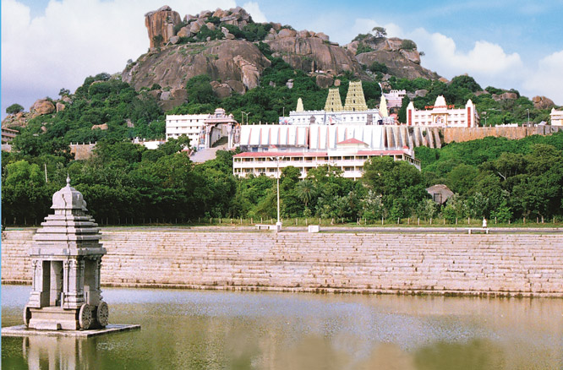

**Fig 2.1:**Adichunchanagiri Mahasamsthana Mutt

**Adichunchanagiri**, also called *Mahasamsthana Math*, is a hill township in NagamangalaTaluk,Mandya District,Karnataka State, India, 110 km west of Bangalore, the capital of Karnataka, India and 6 km from Bangalore-Mangalore National Highway 48, northerly to Bellur cross. Sri Adichunchanagiri Mahasamsthana Math is situated on a rocky hill at an altitude of about 3,300 ft. above M.s.l. It is the spiritual headquarters of the Natha Parampare and Jogi Cult of Hindus of Karnataka.

## Kalabhairaveshwara Temple

Sri Kalabhairaveshwara is the Kshetra Palaka of Sri Adichunchanagiri Mahasamsthana Math. Lord Gangadhareshwara is the presiding deity. The Pancha Lingas, the Jwala Peetha, Sthambamba are all held in great reverence by the devotees. The peak point of the Giri (hillock) is known as Akasha Bhairava and the sacred pond by the temple is Bindu Sarovara. Two lakes have been built for the deepostava programmes. The old Bindu Sarovara was also renovated as per agama tradition.

**History**

Sri Kshetra Adichunchanagiri has a history of 2000 years of its existence. It is the holy land engulfed with the divine resonance and vibration. Ancient Vedic culture was founded here on spirituality, where Nature is valued and worshipped. It was Yagnas and prayers that inspired cosmic peace here.

Sri Kshetra is blessed by Lord Shiva. Lord Shiva performed penance at Sri Kshetra, during which he devoured two demons, Chuncha and Kancha, who were pestering elements of the area for a very long time. At the end of his austerity, Lord Shiva entrusted a Siddayogi, establishing a ‘Natha tradition’ and guided him to disseminate the righteousness in the society.  
Lord Shiva also assured to reside in Sri Kshetra Adichunchanagiri, in the form of Panchalingas viz. Lord Gangadhareshwaraswamy, Chandramouleshwaraswamy, Malleshwaraswamy, Siddeshwaraswamy and Someshwaraswamy; of which Lord Gangadhareshwaraswamy is known as the ‘Presiding Deity’. Thus, Sri Kshetra came to be known as “Panchalinga Kshetra”.

Lord Kalabhyraveshwaraswamy, the manifestation of Lord Shiva, is the ‘Protecting Deity’ of Sri Kshetra. He extends his grace to all and bestows divine experience and liberation. Goddess Parvathi resides here in the form of Stambambike.  
Sri Math serves free food to more than twenty thousand people every day. This feeding programme has earned the Math another name – “Annadani Math”. ‘Bindu Sarovara’ is formed naturally on the middle hill of Sri Kshetra. It is believed that this holy place is formed by the holy water, discharged by the Jata of Lord Gangadhareshwara, who is stationed a few hundred feet high above this lake. Dedicated devotees take a holy dip to dispel their ignorance and accumulatedsins.Sri Kshetra is surrounded by a beautiful forest, which appears to radiate an aura of abiding serenity, spiritual solitude and peace. This area is known as ‘Madura Vana’, where enchanting peacocks live freely.

**CHAPTER -3**

**Fig 2.2:** Heritage tour to Adichunchanagiri Math

**WATER CONSERVATION**

**WHAT IS WATER CONSERVATION?**

Water conservation includes all the policies, strategies and activities to sustainably manage the natural resource of fresh water, to protect the hydrosphere, and to meet the current and future human demand (thus avoiding water scarcity).

For any living being, water is one of the essential necessities and we can not imagine a life without water. It is the natural resource of our earth and its primary constituent. In the nature of different types of life on the earth, water is the universal solvent and plays an important role. For various functions, like washing, bathing, cleaning, cooking, drinking, and other household and commercial uses, it is commonly utilized.

Water is a material that is colourless and odourless and essential for the survival of living creatures. Water sources, like wells, rivers, ponds, reservoirs, seas, massive dams, and streams, are different. Nearly 70 – 80 per cent of the Earth’s surface, as we all know, is filled by water, of which about 1-2 per cent is pure water and appropriate for human usage.

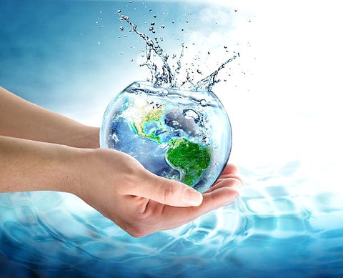

**Fig 3.1**: Water Conservation

### The Need for Water Conservation

It comes as no surprise that water is one of the most essential elements for the survival of any lifeform on the surface of Earth. The presence of water is what makes Earth different from any other planet. The need to maintain the constant flow of water comes from its vitality for the survival of all flora and fauna on the Earth.

Just because a portion of the human population has easy access to water resources, we keep forgetting why saving water is important. Saving water is not only a necessity for humans, our careless waste of water is also affecting the animals and plants around us. There are serious consequences of water depletion.

### Ways to Conserve Water

Water conservation is essential and can be done by everyone. We can all contribute to saving water. Very small-scale changes can be made to preserve water. Even the people who aren’t facing water shortages should find ways to save water at home.

**Techniques implemented for conservation of water**

* **Careful Use of Water:** Keep the taps turned off when not in use. Usage of efficient home appliances like washing machines and dishwashers can save a lot of water. Even without the appliances, make sure you don’t overuse water while washing dishes or clothes.
* **Check for Leaks:** Leaks can cause a significant amount of water loss if left unchecked. So, check the faucet, taps, and pipes for leaks regularly. While turning the tap off make sure to turn it all the way or it may keep dripping.
* **Water the Plants Smartly:** While watering your plants keep in mind the temperature and time of the day, so water doesn’t evaporate quickly. Reuse water from cleaning and laundry to water the plants.
* **Reduce Bathing Water Amount:** While bathing or taking a shower make sure to not let the water run down for a longer period or unnecessarily.
* Rusting pipes Leaky faucets dripping water from shower heads Earth science of unnecessary water wastage that needs to be fixed immediately to avoid wasting water.
* Try using a compost Bin instead of in-sink garbage disposal. Compost bins are environmentally friendly and reduce water wastage

**AGRICULTURAL WELL**

[**Agricultural well**](https://www.lawinsider.com/dictionary/agricultural-well) means a non-potable well used for the watering of livestock, poultry, aquaculture, uses, or solely for the watering of household yards and gardens, or for other purposes related to farming, in general but not including the irrigation of for irrigating lands or crops. Water is not used for human consumption or to service a dwelling.

**What is the use of agriculture in water?**

**Agriculture irrigation accounts for 70% of water use worldwide and over 40% in many OECD countries**. Intensive groundwater pumping for irrigation depletes aquifers and can lead to negative environmental externalities, causing significant economic impact on the sector and beyond.

There are various types of wells, such as **shallow wells, deep wells, tube wells, artesian wells**, and so on. Water from shallow wells is not always available because the level of water drops during the dry months. Deep wells are better for irrigation because their water is available all year.

**Fig 3.2:** Agricultural well visit

**CHAPTER -4**

**ORGANIC FARMIMG AND WASTE MANAGEMENT**

Organic farming can be defined as an agricultural process that uses biological fertilisers and pest control acquired from animal or plant waste. Organic farming was actually initiated as an answer to the environmental sufferings caused by the use of chemical pesticides and synthetic fertilisers.  In other words, organic farming is a new system of farming or agriculture that repairs, maintains, and improves the ecological balance.

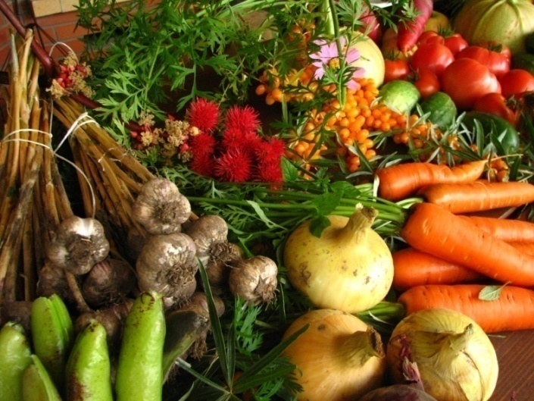

**Advantages of organic farming:**

**Economical:**In organic farming, no expensive fertilisers, pesticides, or HYV seeds are required for the plantation of crops. Therefore, there is no extra expense.

**Good return on Investment:**With the usage of cheaper and local inputs, a farmer can make a good return on investment.

**High demand:** There is a huge demand for organic products in India and across the globe, which generates more income through export.

**Nutritional:**As compared to chemical and fertiliser-utilised products, organic products are more nutritional, tasty, and good for health.

**Environment-friendly:** The farming of organic products is free of chemicals and fertilisers, so it does not harm the environment.

**WASTE MANAGEMENT**

A waste management system is the strategy an organization uses to dispose, reduce, reuse, and prevent waste. Possible waste disposal methods are recycling, composting, incineration, landfills, bioremediation, waste to energy, and waste minimization.

Waste management is intended to reduce adverse effects of waste on human health, the environment, planetary resources and aesthetics. The aim of waste management is **to reduce the dangerous effects of such waste on the environment and human health**.

Biogas or gobar gas is a clean, unpolluted and cheap source of energy in rural areas. It consists of 55−70% methane which is inflammable. Biogas is produced from cattle dung in a biogas plant commonly known as gobar gas plant through a process called digestion. The diagram below shows the process of converting cow dung into gobar gas in a gobar gas plant.

Biogas/gobar gas is an alternate source of energy produced by the breakdown of organic matter in the absence of oxygen. Biogas can be produced from raw materials such as agricultural waste, manure, municipal waste, plant material, sewage, green waste or food waste. Biogas can be produced by anaerobic digestion with anaerobic bacteria, which digest material inside a closed system, or fermentation of biodegradable materials. Biogas or gobar gas is usually 50% to 80% methane and 20% to 50% carbon dioxide, with traces of gasses such as hydrogen, carbon monoxide, and nitrogen.

**Fig 4.1**: Gobar Gas Plant

Gobar gas can be produced in small digesters at home or on a big scale in large [**biogas production plants**](https://www.homebiogas.com/blog/what-is-a-biogas-plant-and-how-does-it-work/):

* Small-scale biogas digesters can provide a low-cost energy source for lighting, cooling, and cooking. The biogas fuel can be consumed directly or converted into power. Depending on the system’s complexity, electricity could also be produced at small costs. It’s an eco-friendly solution that enables households to be self-sufficient while managing waste with minimal impact on the environment.
* Gobar gas can generate heat, electricity, or heat and power (CHP) plants when it is produced in large quantities in industrial facilities. Depending on the size of the biogas plant, the energy produced can be directly sent to the electricity grid and serve one or several communities. Moreover, the heat produced during the process can also be used to heat pools or buildings nearby. If the biogas is purified to produce biomethane, this can replace natural gas in industrial, commercial, and residential applications. The fuel is easily transportable.

**Fig 4.2**: Gobar Gas Plant visit

**CHAPTER -5**

**FOOD WALK**

During a food walk, **you usually go out with a group of people, led by a local expert who is a food lover too**. You walk down a locality and try to get under its skin through its food. You don't always have to 'walk' though. There could be variations.

Food walks form an integral part of culinary tourism across the world today. It's a fun concept to take part in if you are a food lover and are interested in understanding people and their lives through the lens of food, while munching your way through some delicious treats. During a food walk, you usually go out with a group of people, led by a local expert who is a food lover too.

Benefits of food walk:

* Immersion into local or street food culture.
* History and traditions behind the food we eat.
* Supporting local economies by patronizing small businesses and food markets.
* Oppourtunities to try unique and authentic dishes.

**Fig 5.1:** Food Walk

**Importance of Nutrition:**

The essential nutrients are vitamins, minerals, proteins, fats, water and carbohydrates. People need to consume these nutrients from dietary sources for proper body function. Essential nutrients are crucial in supporting a person’s reproduction , good health, and growth.

**Protein:**

Protein is having its moment, and not just in the workout community. But all of the hype is for a good reason. Protein is essential for good health.

Protein provides the building blocks of the body, and not just for muscle. Every cell, from bone to skin to hair, contains protein.

A startling 16 percent of the average person’s body weight is from protein. Protei is used primarily for growth, health, and body maintenance.

All of your hormones, antibodies, and other important substances are composed of protein. Protein is not used to fuel the body unless necessary.

**Carbohydrates:**

Don’t let the low-carb craze fool you. Carbohydrates are necessary for a healthy body. Carbs fuel your body, especially your central nervous system and brain, and protect against disease, according to the Mayo Clinic.

Carbohydrates should make up 45 to 65 percent of your total daily calories, according to the Dietary guidelines for Americans.

**Fats:**

Fats often get a bad rap, but recent research has shown that healthy fats are an important part of a healthy diet.

According to Harvard Medical School, fat supports many of your body’s functions such as vitamin and mineral absorption, blood clotting, building cells, and muscle movement.

Yes, fat is high in calories, but those calories are an important energy source for your body.

**Vitamins:**

Vitamins are vital for warding off disease and staying healthy. The body needs these micronutrients to support its functions. There are 13 essential vitamins that the body needs to function properly, including vitamins A, C, B6, and D.

Each vitamin plays an important role in the body, and not getting enough of them can cause health problems and disease. Many Americans do not get enough of many essential vitamins. Vitamins are essential for healthy vision, skin, and bones.

**Minerals:**

Much like vitamins, minerals help support the body. They’re essential for many body functions, including building strong bones and teeth, regulating your metabolism, and staying properly hydrated. Some of the most common minerals are calcium, iron, and zinc.

In addition to strengthening bones, calcium helps with nerve signal transmission, maintaining healthy blood pressure, and muscle contraction and relaxation. Iron supports your red blood cells and hormone creation, while zinc boosts your immune system and wound healing.

**Water:**

You can go for weeks without food, but you can’t last more than a few days without water. Water is absolutely crucial for every system in your body. It’s also the main thing you are made of. About 62 percent of your body weight is water.Water improves your brain function and mood. It acts a shock absorber and a lubricant in the body. It also helps flush out toxins, carry nutrients to cells, hydrate the body, and prevent constipation.

**Fig 5.2**: Food walk in our college